3. Database scheme (diagram finish)
explain the index created. Why?
Faster query, it takes a lot of time especially for special join without indexes.
-spatial index on geom makes query returns faster for ST_Contains, St_Overlaps, etc
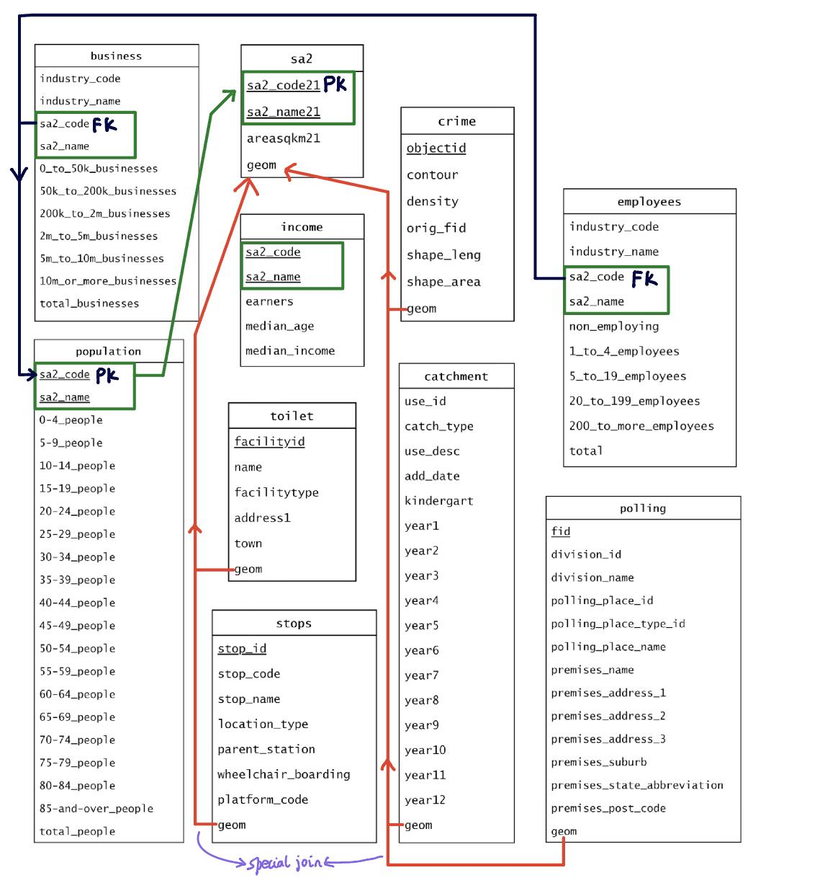
-we also create index on sa2_code
We join income with final sigmoid_2
table using sa2_code.
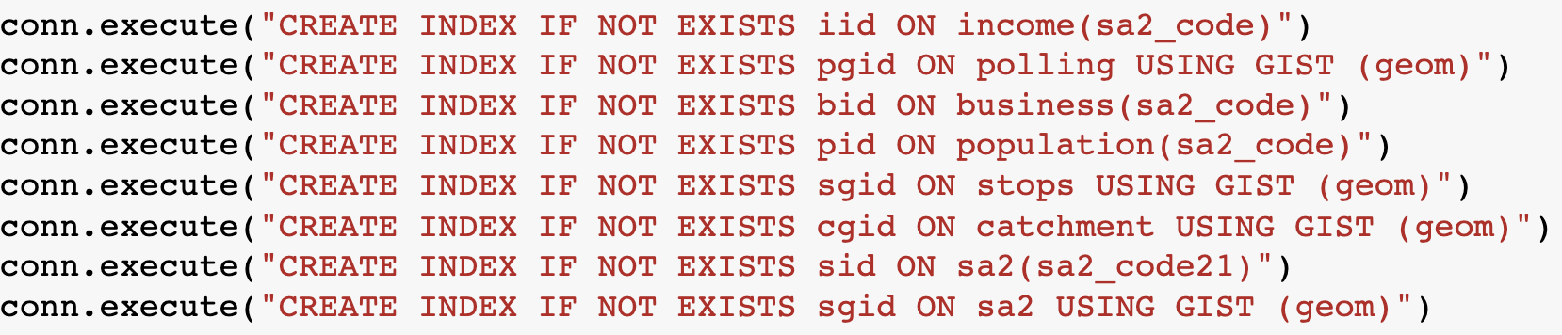

https://dataschool.com/sql-optimization/how-indexing-works/#:~:text=Indexing%20makes%20columns%20faster%20to,row%20until%20it%20finds%20it.

B. SCORE ANALYSIS a
What is zscore what does it represent
, sigmoid means?
-general formular
- graph + table join + graph analysis
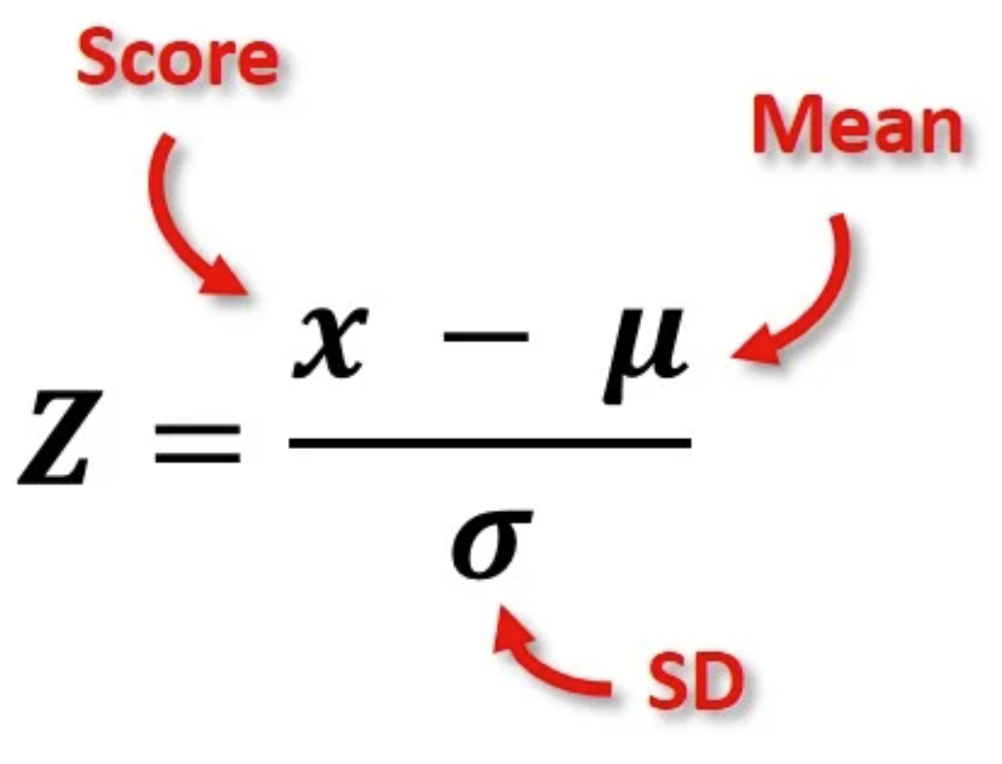
General formula: For each score they are divided either by area, or by people. As we only calculate scores for areas with at least 100 total people, these areas and people will be converted to NaN so its final z-score is also NaN. In our pre-check, sa2’s area has no NaN as well as total people and young people. Hence, with a restriction of 100 people, NaN z score should only happen when the region has less than 100 people. As NaN is excluded in calculation of mean and sd, the score won’t be affected.
The process of transferring score to z-score is the same

1. Formula: Retail score is the number of businesses in retail trade divided by total people in that region (sa2) and multi 1000.
Index used for calculation: We join business with sa2 by sa2 code (Actually join business with population, sa2 and population are kinda same, we merged people columns into sa2) .
Limitations: Some areas have a population of less than 100, so we have to convert all total_people less than 100 to nan, otherwise some of these scores would be large and affect the z score and visualization.

2.Formula: Health score is the number of businesses in the healthcare and social assistance section divided by total people in that region (sa2).
Index used for calculation: We join business with sa2 by sa2 code. Same with Retail.
Limitations: The score is per 1000 people, but the regions with less than 1000 people exist

3.Formula: Stops score is number of stops per area sq km
Index used for calculation: We identified that stops are formed as points, and the area should contain points, so we use ST_contains. When getting the stops’ score, then convert to z score.
Limitations: None

4.Formula: Polling score is number of polling locations per area sq km
Index used for calculation: We identified that polls are formed as points, and the area should contain points, so we use ST_contains, and follow the steps with stops.
Limitations: None

5.Formula: School score is the number of schools divided by area of sa2 region.
Index used for calculation: Since school can be shared between 2 areas, we use ST_Overlaps so 1 school can be counted for all areas cutting it. We then get the school score and convert it into z score.
Limitations: Raw school data contains duplicated school areas, however most of them are different in catch types.
Interesting findings:Future catchment differs from primary and secondary records.

6.Formula: Toilet score is the total counts of public toilets divided by area of sa2 region.
Index used for calculation: We count the number of public toilets that each sa2 region area contains. Then we get the toilet rate per area and convert it into z score.
Interesting findings: The rate of toilets is higher in smaller sa2 region areas.
Limitations: None

7.Formula: Crime score is crime area divided by area of sa2 region. Raw crime data has some NaN is crime area, that means z score of these areas will also be nan. However nan z score is only for areas with less than 100 people, hence we replace the crime area of nan with 0, which means that area has no crime.
Index used for calculation: We found overlapping area between crime area and sa2 region area. Then we get the crime rate per area and convert it into z score.
Interesting findings: There is a weak positive correlation between crime score and median income (0.22), which indicates almost no relationship between crime and income. However we expect that higher income areas means less crime, since crime can come from financial stress (income, employment), social stress (social standing, inequality).
Limitations: we do not know if nan crime data is due to the crime area being super small, super big or no crime because the data isn’t full. However we are giving a good score (0 crime) for these unknown areas, therefore, the final z score may be biased. Also, the crime score doesn’t reflect the area's whole “crime” aspects because the data set is limited to domestic assaults only, it does not include house breaking, vehicle stealing etc…

8.Formula: non-employing is the number of non employing construction industries per 1000 people, to be more specific is the number of industries which didn’t hire employees.
Index used for calculation: We join employees with sa2 by sa2 code (Actually join employees with population, we merged people columns into sa2).
Limitations: The nan exists, and the score is per 1000 people, but the regions with less than 1000 people exist.

99. Overview
-sigmoid score interpretation (can combine with graph analysis)
-the implications of extending the base formula with additional datasets
-graph analysis
+summary of overall distribution
+trends
+support by relevant table if has
-> this is the final sigmoid graph.
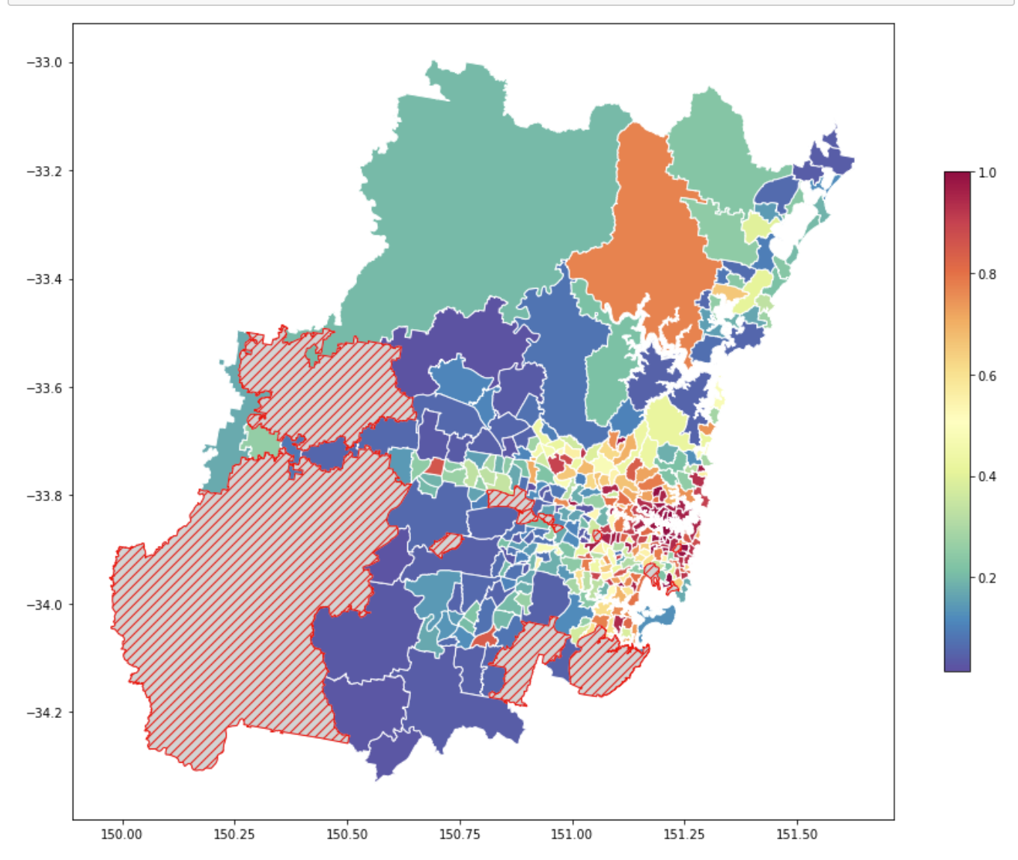
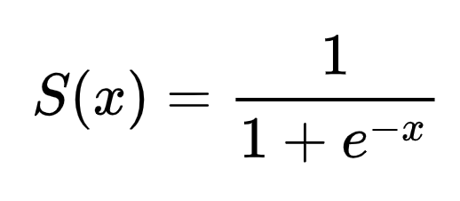
The Sigmoid function converts the summary (+ if the score has a positive impact on well_resourced, - if not such as crime ) of the z score to a probability value between 0 to 1, which represents the degree of the well resourced score. Based on the plot and quantile, we can see areas with high Well_resourced scores are concentrated in the city of Sydney.

DRAFT

score (3 parts)
-formula -if use st_contains/ st_overlaps, the use of index

-comment on the score + interesting finding (mathematically)
-limitation

2. Interesting findingsas\

ORIGINAL SCOREasd
- business <retail per 1000 pp>
In examining the relationship between retail business development and median income. We discovered a weak correlation of 0.007101 in the correlation table between retail scores and median income. This implies that areas with higher median incomes tend to attract more retail businesses, likely due to perceived market potential and residents' purchasing power.

Moreover, the influence of socioeconomic factors becomes evident, as regions with higher median incomes often boast a more robust retail sector, potentially fostering local economic growth and employment opportunities. These findings shed light on the multifaceted dynamics between median income and the retail industry, highlighting the role of socioeconomic factors in shaping retail distribution.

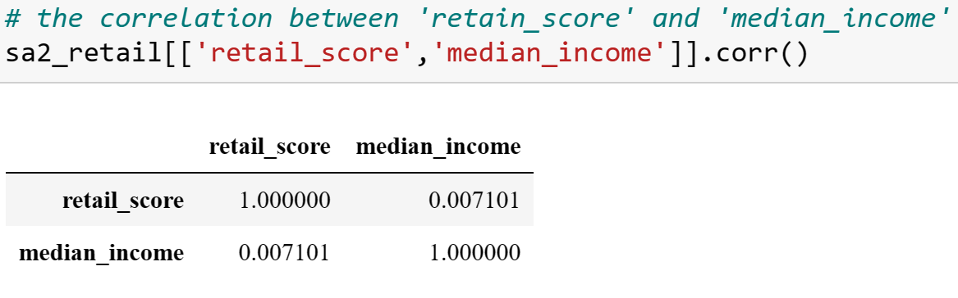
- business < health per 1000 pp>
In our study, we found that the correlation between median income and health service -0.014701 is negative, It could imply that lower-income areas may face challenges in accessing adequate healthcare resources, while higher-income areas may have better healthcare facilities and services.

The correlation could highlight the potential influence of socioeconomic factors on health service availability. It may indicate that socioeconomic disparities could contribute to variations in health service provision, with higher-income communities benefiting from better healthcare infrastructure and resources.

These findings have significant implications for healthcare disparities. They underscore the need for policies and interventions aimed at addressing the inequitable access to health services across different income levels. Efforts should focus on narrowing the gap and ensuring that all individuals, regardless of their income, have equal opportunities to receive quality healthcare.

By implementing targeted strategies, such as increasing the availability of healthcare facilities in underserved areas and providing financial assistance programs for low-income people, we can work towards achieving equitable access to healthcare. Furthermore, improving health education and awareness within lower-income communities can empower individuals to make informed decisions about their health and seek appropriate care when needed.

Addressing healthcare disparities requires a multifaceted approach that embraces policy changes, resource allocation, and community engagement. By prioritizing equitable access to healthcare services across income levels, we can strive towards a fairer and healthier society for all.

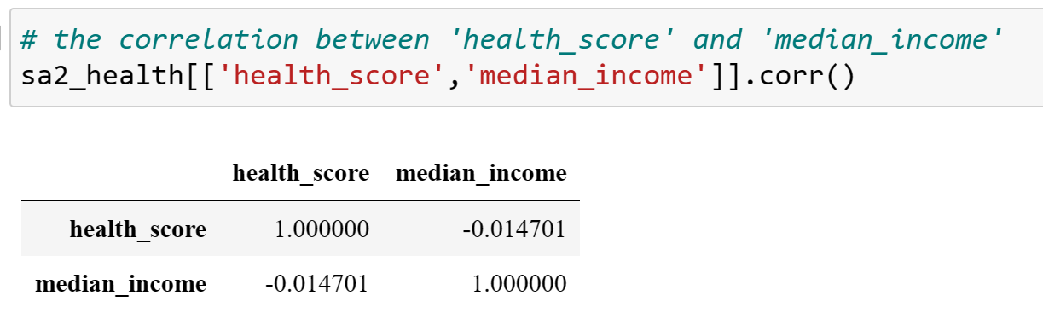
- polls <POINT: number of polling locations>
While the correlation coefficient between polling locations and median income is extremely small (-0.007786), indicating a minimal negative correlation, it raises intriguing questions about the relationship between these factors. The influence of socioeconomic factors becomes apparent, as variables like education levels, employment opportunities, and social dynamics may contribute to this relationship.

Despite the weak correlation, there appears to be a subtle tendency for areas with higher median incomes to have slightly higher polling scores. This suggests that economic conditions, to some extent, may influence satisfaction levels and voter engagement. It highlights the potential impact of policies and initiatives on polling scores, as well as the need to consider economic factors when analyzing voting patterns.

However, it is important to note that the correlation coefficient is close to zero, indicating an extremely weak and negligible association. This implies that other factors, such as political ideologies, demographic composition, or local issues, may have a more significant influence on polling scores than median income alone. Further research is necessary to delve into the intricate interplay between these variables and to identify the key drivers of voting patterns.

Understanding the complex dynamics between polling locations, median income, and various influencing factors is crucial for policymakers and researchers. It can inform the development of targeted strategies to enhance voter participation, address disparities, and promote a more inclusive democratic process. Through a careful study of these relationships, we can gain valuable insights into the factors that shape electoral outcomes and work towards a more comprehensive understanding of democratic engagement.

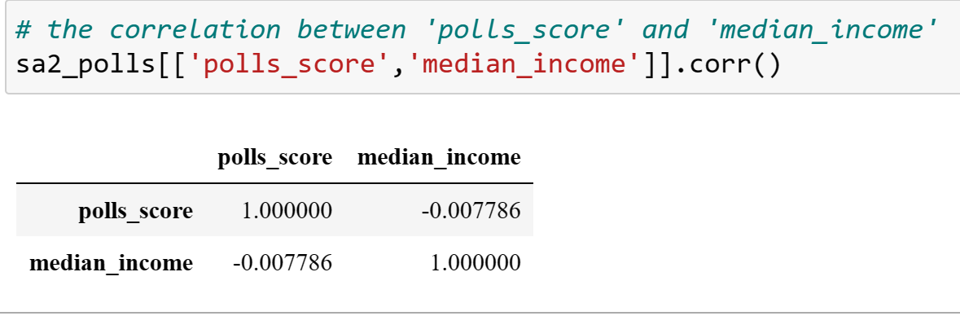

EXTENDED SCOREasd
- toilet <POINT: number of toilet per area_square>
The results of our study showed that the correlation of 0.039932 between toilet count and median income indicates a very weak positive correlation. This suggests that there is a slight tendency for areas with higher median incomes to have a slightly higher toilet score. It implies that areas with higher median incomes might have slightly better sanitary facilities and higher scores in terms of toilet cleanliness and availability.

The findings suggest that areas with higher median incomes may prioritize investments in improving and maintaining public toilets. This could be attributed to the desire to provide better facilities and amenities for residents in these affluent neighborhoods. The availability of clean and well-maintained toilets contributes to a higher quality of life and enhances the overall experience for individuals living in higher-income areas.

Moreover, the correlation highlights the broader connection between median income, quality of life, and the availability of essential amenities. Higher toilet scores in higher-income areas indicate a more favorable sanitary environment, which in turn contributes to improved hygiene, comfort, and convenience for residents. This demonstrates the potential impact of socioeconomic factors on the provision and accessibility of essential services.

These findings underscore the importance of considering income disparities and socioeconomic factors when assessing the availability and quality of amenities. They highlight the need for policymakers and urban planners to ensure equitable access to essential facilities, including toilets, regardless of income level. By addressing disparities in sanitary infrastructure, communities can promote better hygiene practices and enhance the overall well-being of their residents.
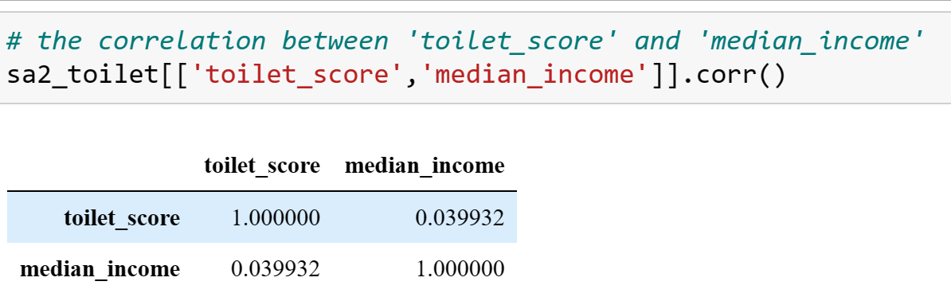
- crime <POINT: area of crime per area_square>
Firstly, the positive correlation coefficient of 0.215537 between crime rates and median income indicates a weak positive correlation, challenging the assumption that higher incomes directly lead to reduced crime. This suggests that education, employment, and social inequality might significantly influence crime rates. It highlights the complexity of the socioeconomic factors impacting crime, requiring a broader perspective.

Secondly, exploring areas with higher median incomes but lower crime scores presents an intriguing phenomenon. These regions serve as potential case studies to identify effective crime prevention strategies that successfully mitigate crime despite higher incomes. By examining the initiatives, community programs and social factors at work, we can uncover valuable lessons to replicate in other areas grappling with crime issues.

Moreover, identifying outliers where the correlation between crime rates and median income deviates from the general trend is of particular interest. These outliers represent exceptional cases where other influential factors overshadow the impact of median income on crime rates. Investigating these unique situations can uncover hidden drivers and bring attention to specific circumstances that warrant further exploration and targeted intervention.

In conclusion, the fascinating findings discussed in this report highlight the complexity of the relationship between crime rates and median income. The weak positive correlation challenges our traditional beliefs and emphasizes our need for a deeper understanding of the intricate relationship between education, employment, social inequality, and crime rates. By studying regional variations, successful crime prevention strategies, and outliers, we can gain valuable insights to guide more effective policies and interventions. This comprehensive understanding will enable us to tackle crime-related challenges with a holistic and evidence-based approach.
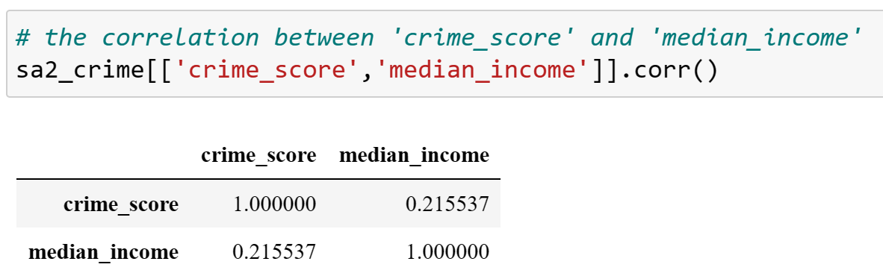
3. Score limitationsas\
However the limitations exist that some areas with low populations but a high number of factories also have relatively high scores, and these may also have very low levels of crime, although other measures are lower. These places cannot strictly qualify as well resourced places and may be confusing to researchers.

as\4. Key conclusions\
as\5. 1 index used for calculation (?)as\

C. CORRELATION WELL RESOURCED SCORE & MEDIAN INCOMEasd

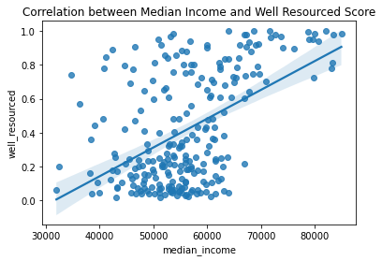
Based on the plot, there is a positive relationship between well_resourced score and median income.

USEFULNESS: This plot carries a regression line to present correlations more clearly. It can also provide hints of regional development and improvement by understanding the relationship between median income and well_resorced.

LIMITATIONS: However, identifying the sa2_region represented by the point in the plot may be a little bit tricky. In addition, to get a more accurate well resourced score, it is necessary to explore a wider range of resource data.

